The Leaders in Magnetic Shock Mitigation Footwear Technology and More…

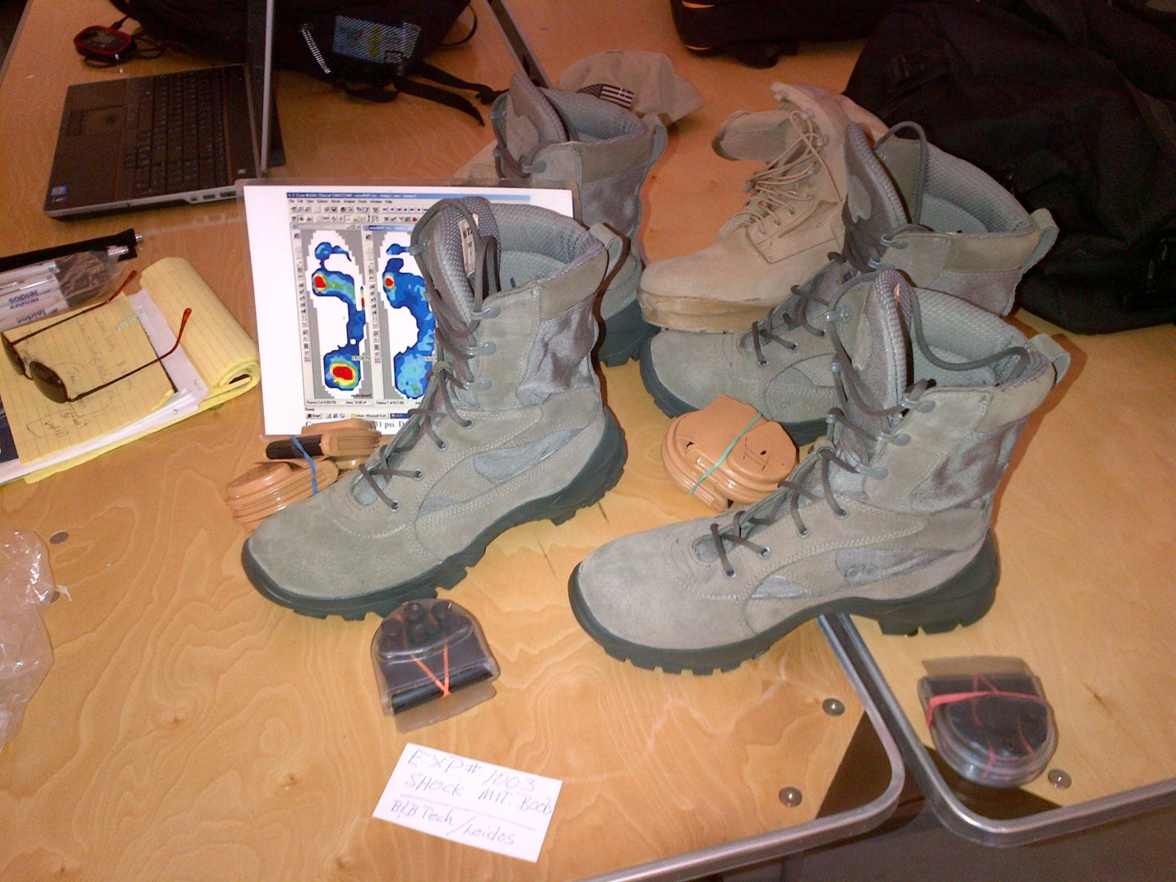
Invitation Only Special Operation Forces Shock Mitigation Experiment FT. Story, VA

Introduction Platform I
Hello I am Jeff Brown and welcome to the proprietary DAMPS (Directional Axial Magnetic Propulsions Systems) the future of shock mitigation technologies for the military, commercial work, women's and medical footwear markets.

Benefits
Over 68% reduction in heel strike was recorded for SOF (Special Operation Forces). Anyone can walk ten miles and save your body the shock of seven. Plantar Fasciitis (heel strike injury) is the number one injury seen by podiatrists. Low back problems are the number two cause of employee downtime.
Shock is the enemy
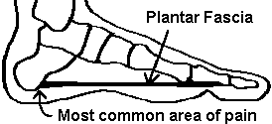
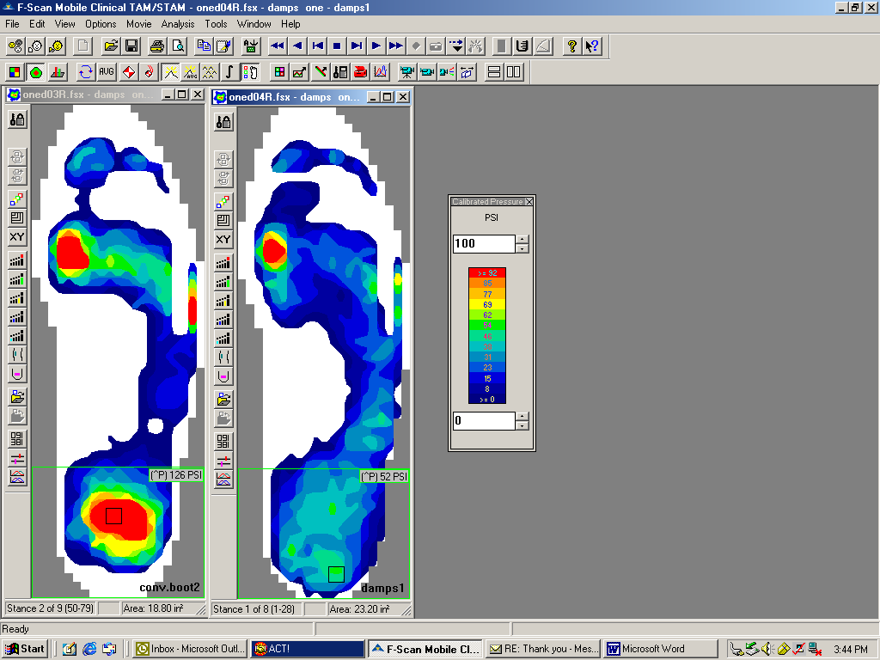
F Scan the Leaders in Pressure Surface Mapping.

Background
We received out first Special Operation Forces (SOF) contract in 2004. After ten years of privately funded R&D and operator testing, DAMPS technology MKV Delta < 9 > Smart boots were voted "Super Stars" at the invitation only SOF Shock Mitigation Experiment Ft. Story, VA 2014. We are now pending a FY2018 shock mitigation program with the Navy Seals on their Fast Attack Boats. Our military POC is Jon Nussbaum and is available for questions, Jon.k.Nussbaum@leidos.com

Platform I Offering
With a management based $10 million Technology Intellectual Property Good Will valuation, we are looking initially for $5.5 mil. in convertible debt equity funding for USA based commercial manufacturing ramp up. We will pledge 51% equity in our Regulation D Rule 506 Form D filing, until our projected year two payback, plus 8% interest, with designated term equity retention TBD. www.damps.com

Super Magnetic R&D Beginnings
General Motors owned the patent for rare earth super magnets. We were under NDA with GMs magnet division, AC Delco Remy and Magnequench in 2002, exploring understanding and testing the potential of super magnetics. General Motors would be our first choice to partner with. DAMPS can add a billion dollars to a forward looking car manufacturer’s bottom line, in five years or less.

Strategic Marketing Footwear is Transportation
This one of a kind plan to market this premium branded footwear technology with exclusive LOI’s with brick and motor car manufacturers may be at first a question mark. The answers are a paradigm shift for a multi-billion technology, in a $ 300 + billion worldwide footwear market.

Utilizing exclusive stand alone DAMPS kiosks in dealerships, with coordinated online sales marketing and distribution, our strategic plan markets this premium branded footwear technology with exclusive LOI’s to car manufacturers.

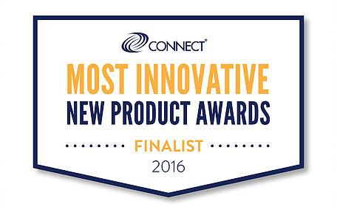

Platform II Non Boot Ancillary Shock Mitigation Technologies Offering Options
- Women’s footwear.
- Shock mitigation helmet liners with the OACS (Opposing Articulated Composite
Springs) system, recorded over 70% impact load reduction in computer simulations.
Concussion and CEI are very much in the sports news.
- Commercial and recreational vehicle seat cushions would be big with NASCAR’s demographic.
- More magnetic shock mitigation technology products in development.

Womens Prototypes with LOMS (Load Off Modular System)
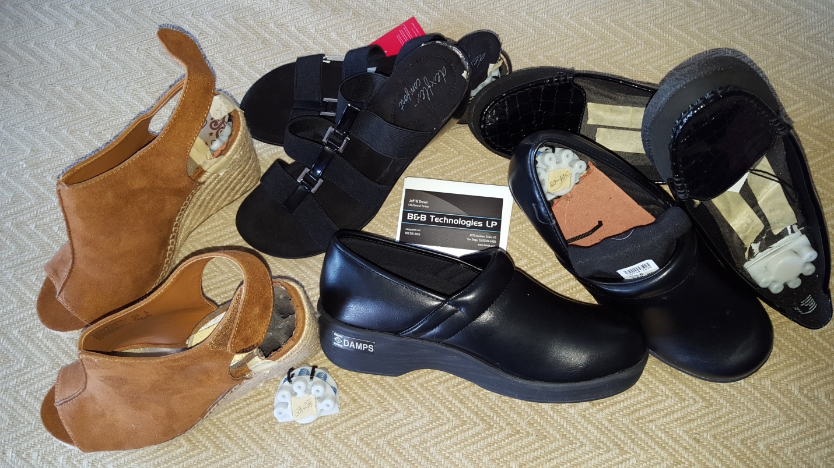

Dual Magnetic/OACS Shock Mitigation Vehicle Seat Cushions

Sports Helmet Liner with OACS
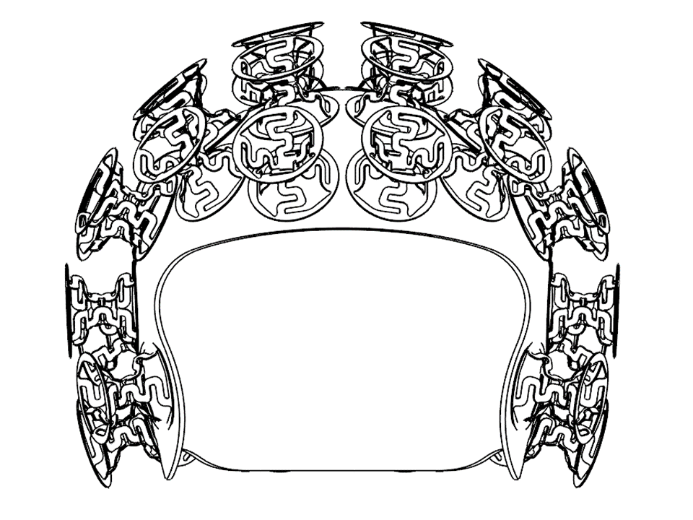

A Title III Series A Regulation A Tier I is now in secondary SEC qualifying review to raise one and up to twenty million dollars with unaccredited and accredited investors. 100,000 preferred shares @ $10 par value. www.TechnologyIsFashion.com

A Regulation D Rule 506(c) has been filed with the SEC for accredited investors to raise unlimited funding for manufacturing licensing. www.TechnologyIsFashion.com

Platform I investors receive exclusive negotiated DAMPS license royalties from Platform II non boot DAMPS technologies.

With the Regulation A, our goal is to open up investment availability/participation to the military and working men and women. $100 minimum investment.

The DAMPS I LP Investors would consider Exclusive Licensing, Buyout or Acquisition.

Valuation Metrics
- Footwear Boots
Military
Commercial
Medical; F Scan pressure surface mapping shock mitigation data from Navy Seal Maritime and Dismounted Testing to be utilized for a 510(k) Medical device, for the prevention and treatment of repetitive back and lower extremity impact injury and plantar fasciitis (heel strike injury).
Power harvesting chip (with Texas Instrument)

- Women’s
Fashion
Professional
Work
Sports et al (Proprietary outsole formulations) Developed with Good Year Tire and Rubber and one with Lawrence Livermore National Labs. Currently the lightest weight (Specific Gravity) and highest resiliency (Bayshore) of any outsole formulation on the market today and no one knows about us

- Sports Helmet Liner
Pee Wee
High school
College
Professional
Ancillary Sports; Hockey
Bike
Motorcycle

- Seat cushions
Motorcycles’
Buses
Trucks
Heavy Equipment
Tractors
Cars
Total market size
Revenue generation
Potential technology market penetration
Time to market saturation
Option for Exclusive Licensing, Acquisition or IPO Exit

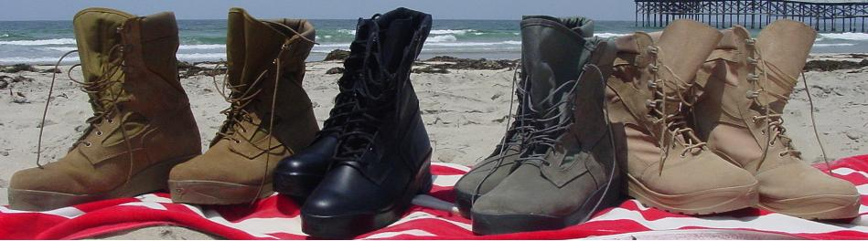

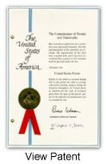

Charles Fallow
Shoemaker and Mattare Ltd.
Silver Springs, MA 20110

Michael J. Bujold
Davis Bujold P.L.L.C.
Concord, NH 03301--2931

Jody Drake
Sughrue Mion PLC
Washington DC
2100 Pennsylvania Avenue, NW
Washington, District of Columbia 20037-3213

Intellectual Property (IP)
- Two Modular Footwear Shock Mitigation Design patents Issued
- International Design coverage with the Haig Convention; thirty three countries in the EU and Japan.
- One Modular Footwear Shock Mitigation CIP Utility patent pending (Includes Power Harvesting Chip with Texas Instrument)
- One Utility patent pending Shock Mitigation Sports Helmet Liner.
- One Provisional patent filing (Vehicle Seat Cushion)
- Four utility patents pending filing.
- Four Proprietary Trade Secret outsole rubber formulations developed with Good Year Tire and Rubber. One with Lawrence Livermore National Labs.
Currently the lightest weight and highest resilient outsole formulation available
- DAMPS TM
- Six website domain names.
- Various trade secret marketing campaigns

Five Year Sales Projections are Available by Request

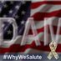

The DAMPS I Advisory Board
NBA Hall of Famer Bill Walton
Ed Stone President of Boot World 35 years in the industry
Bob Hollenbaugh 45 year VP industry insider
Jon Nussbaum our SOF Military POC from Leidos
Dr. Dr. John Ciccone DPM consulting podiatrist, deceased
Dr. Harold Barry 35 year VP industry insider, deceased

Social Media is the New Word of Mouth
Twitter @MagnetBootGuy
You're Either One Step Ahead or Two Feet Behind
DAMPS Technology Delta <9> Smart Boots http://damps.com #DAMPS #USA #TMF
Looking forward to our next best magnetic steps.

Sincerely,

Jeff Brown
CEO/General Partner
B&B Technologies LP
President
Shock Mitigation Technologies Inc. (SMT)
858 581-9015
619 889-6397
ceogp@att.net
www.damps.com
www.TechnologyIsFashion.com

“Relatively speaking, we’ve got to be smarter than our shoes.” LOL

